LET'S COMPARE THE FARM ANIMALS (primerjajmo živali na kmetiji)
- Look , read and learn (Poglej, preberi in se nauči)
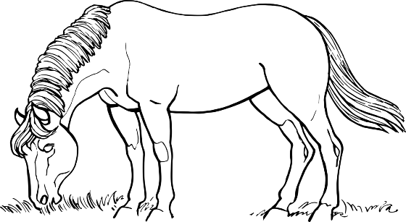 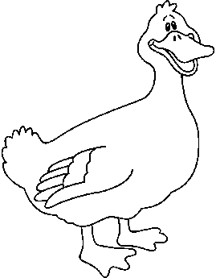 The horse is BIGGER THAN the duck. (večji kot).
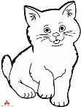 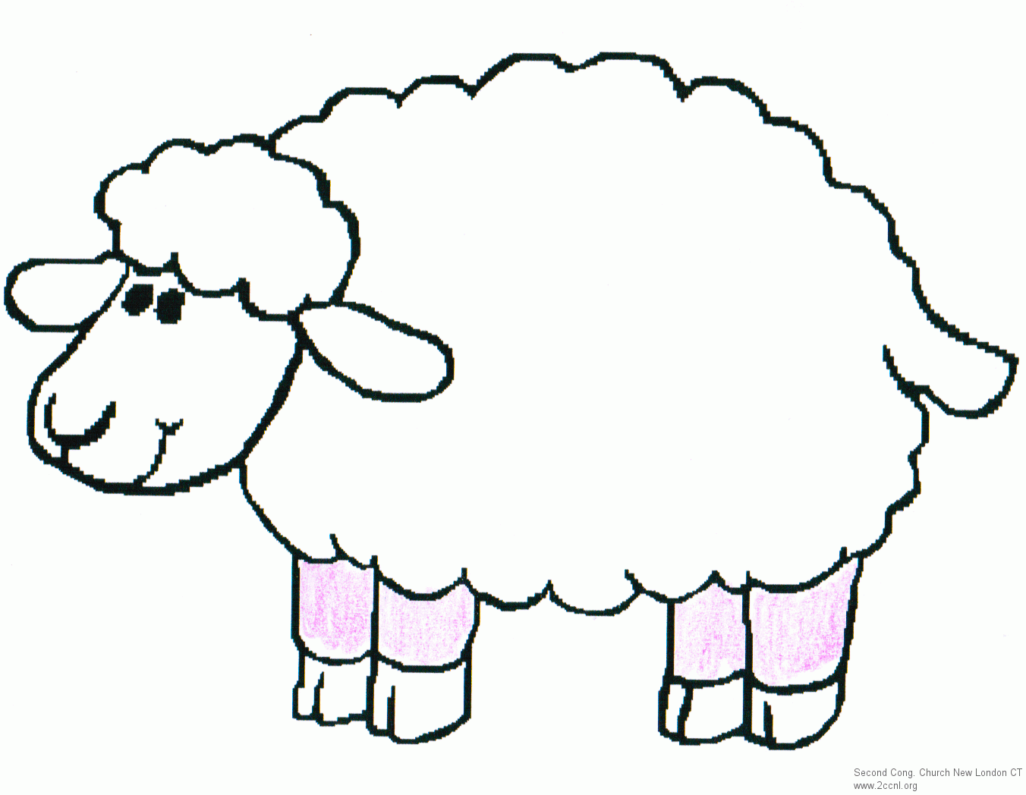 The cat is SMALLER THAN the sheep (manjša kot).

- Write the sentences (Napiši povedi).
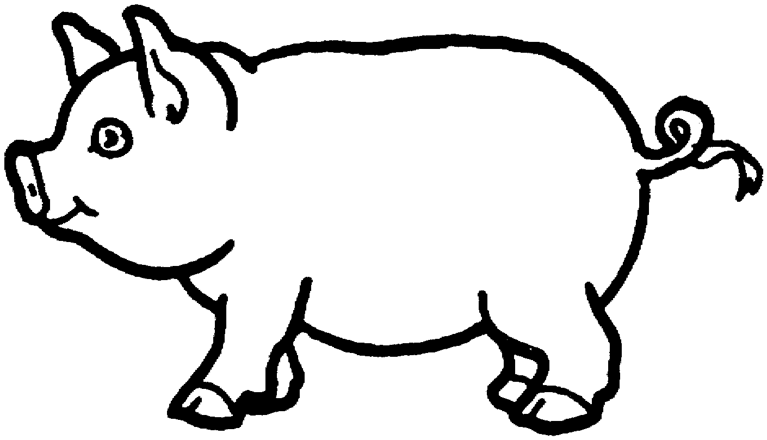 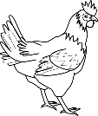 The pig is _______________________________________________________
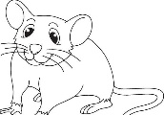 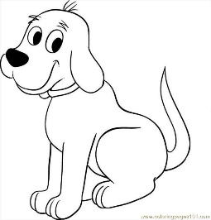 The mouse is ____________________________________________________
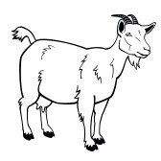 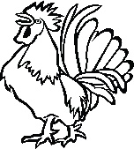 The goat is ___________________________________________________

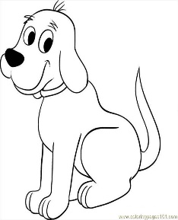 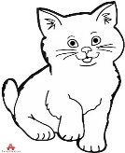 The dog is ___________________________________________________

