6. 4. – 10. 4. 2020
Navodila za delo TJA, 2. RAZRED
Tuesday, 7th April (torek, 7. april)
- Watch the video first// Najprej si oglej posnetek: https://youtu.be/90skFwUmDZs

- Open your Notebook and talk about your shapes// Odpri svoj zvezek in govori o tvojih likih. (It's a red triangle….na primer)
- Write the title// Napiši naslov: MORE SHAPES// VEČ LIKOV
- WRITE// Napiši:
a circle- 5/ five circles a square- 3/ three squares an oval- 0/ no ovals
a rectangle- 2/ rectangles a triangle- 4/ four triangles a star- 7/ seven stars
a heart- 10/ ten hearts a diamond- 2/ two diamonds

- Look at the picture, draw and describe the robot. // Poglej sličico, nariši in opiši robota

There are 3 .(There are three triangles.) - tako poveš (Tega, kar je v oklepajih, ni treba pisati, lahko pa)
There are 2 . (There are two squares.- TAM STA DVA KVADRATA)
There are 6 . (There are six circles.- TAM JE ŠEST KROGOV))
There are 6 . (There are six stars- TAM JE ŠEST ZVEZD)
There are 0 . (There are no rectangles.- TAM NI PRAVOKOTNIKOV)
There is 1 . (There is one heart- TAM JE ENO SRCE)
There is 1 . (There is one oval- TAM JE EN OVAL)

Thursday, 9th April (četrtek, 9. april)
- Write the title// napiši naslov: EASTER TIME// velikonočni čas
- Nariši sličice in napiši besede:
A CHOCOLATE BUNNY// CHOCOLATE BUNNIES//
čokoladni zajček čokoladni zajčki

CHOCOLATE EGGS// AN EASTER EGG// velikonočno jajce
čokoladna jajčka

EASTER EGGS// velikonočna 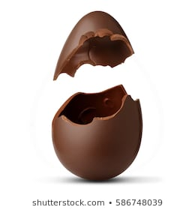 A CHOCOLATE EGG// čokoladno jajce
jajčka
AN EASTER BUNNY// velikonočni zajček

- Now watch the cartoon related to Easter time// Zdaj si oglej velikonočno risanko https://www.youtube.com/watch?v=xCthmJqXsuc
- ENJOY EASTER TIME! // UŽIVAJ V VELIKONOČNEM ČASU

