Hello again, my dear students.
How is life inside the house?
What are you doing these days – drawing, writing a book, playing video games, reading, playing board games, gardening on your balcony, cooking, baking …?
I’m looking forward to hearing from you. You can always write an e-mail to talk to me. (And you can freely do it in Slovene.)
I must say a big THANK YOU to everyone who already wrote a letter. I was very happy!
And how is your English?
Let’s learn some more!
- CLOTHES
Ponovi poimenovanja za oblačila – v zvezku, kamor si prepisal-a besede, pokrij slovenske besede in se preveri, koliko angleških razumeš. Ko boš znal-a vse prevesti v slovenščino, prekrij angleške besede in se preveri, koliko znaš. Vadi tako dolgo, da boš zadovoljen-na s svojim znanjem.
POMEMBNO! Imamo nekaj oblačil, ki so besede v množini – TROUSERS / PANTS, TIGHTS, SOCKS, GLOVES …- te besede nimajo A/AN, vse ostale pa – npr.: I'm wearing a T-shirt and socks, trousers and a cap.

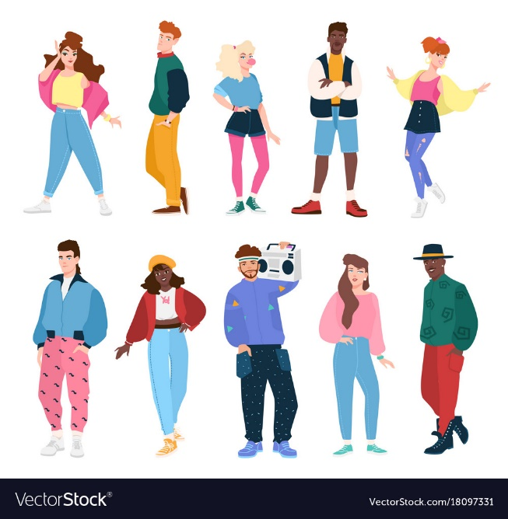
S spodnje slike izberi 4 ljudi, daj jim imena in v zvezek zapiši, kaj imajo oblečeno. K oblačilom dodaj tudi barvo – npr. a blue dress in napiši, če ti je oseba všeč. I like/I don't like him/her.

- REVISION – ponavljanje in utrjevanje
Na spodnjih povezavah lahko utrjuješ znanje letošnjega šolskega leta:
URA:
https://www.gamestolearnenglish.com/telling-the-time/
https://www.eslgamesplus.com/time-daily-routines-expressions-esl-grammar-sentence-activity/
https://www.mes-games.com/whattime.php
ŠOLSKI PREDMETI:
https://learnenglishkids.britishcouncil.org/word-games/school-subjects
https://www.liveworksheets.com/worksheets/en/English_as_a_Second_Language_(ESL)/School_subjects/School_subjects_-__likes_and_dislikes_he10055nt
STAVBE V MESTU:
https://www.liveworksheets.com/worksheets/en/English_as_a_Second_Language_(ESL)/Places_in_the_city/Places_in_town_vi1055ik
ŽIVALI:
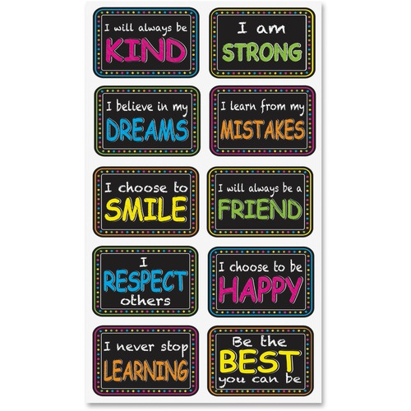
https://www.eslgamesplus.com/zoo-animals-esl-vocabulary-interactive-game-canon-volley/

That's it for this week.
Stay well and keep in touch.
Your English teacher

